**Development of Dynamic Infographic – Volatility and Adoption Index - Proposal**

**Understanding of the project**

Develop automated and dynamic infographic for volatility and adoption index for 8 specified industries for four quarters

**Scope**

* Industries specified are: Life sciences, capital markets, insurance, commercial banking, retail banking, healthcare provider, manufacturing, healthcare payer, consumer packaged goods
* There will be comparison of only two quarters at a given time for a single industry
* Only single industry will be visible at a given time
* All charts will be dynamic and automated pulling data from a common file *(proposed solution)*
* Data is to be displayed as charts for:
* Total volatility index
* Companies impacted
* Sharing the reports via email/ thumbnails *(additional effort of 4 days)*
* Avg. number of volatility events
* Event types:
  + Restructuring
  + Leadership change
  + Pressure on financial condition
  + Industry wide, geographic or regulatory change
  + Acquisition or expansion
* Does not include hosting – Genpact server will be used for the same
* Automating the main / common infographic *(additional effort of 8 days)*

**Assumptions**

* Updated data will be provided by Genpact for all quarters
* There is no calculation required and data shared by Genpact will be final/calculated data
* The basic metrics displayed will not vary – only the data will change for each quarter / industry
* The number of charts will not change with time
* Interface will follow genpact branding standards
* Genpact server/ website will be used for hosting the infographic. GT will provide a packaged file for the same
* GT will need support from genpact web team for upload and testing of the developed application – in interim GT will use its own server space

**Proposed solution**

* Create Html interface for dynamic/ automated Infograph – the look and feel will be similar to as shown below
* Bar graphs will be created using JQuery
* Automatic quater data update will be done using JSON file (Similar to CSV)

***Sample interface*** *(just a sample for reference and will be finalized after project is formally started)*

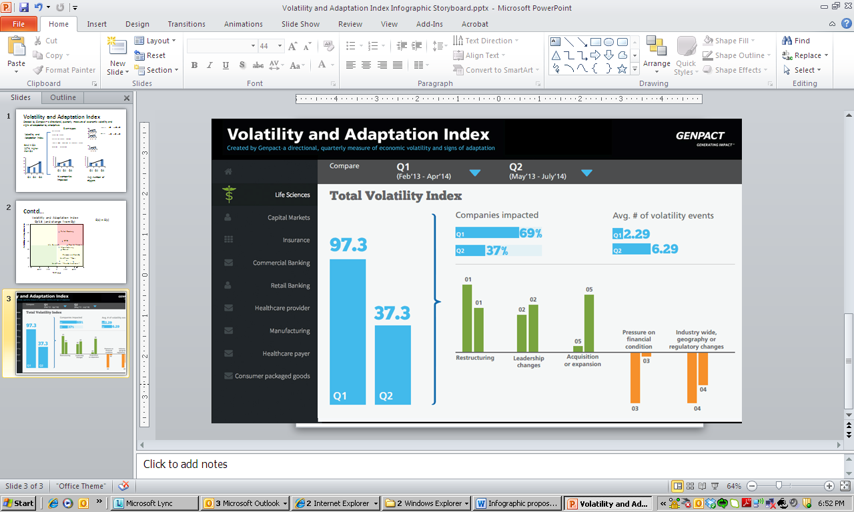

**Timelines:** It will take **~ 15 working days** to have the application developed and tested

*NOTE: Any additional effort or change might change the proposed timelines and cost*